**How to change battery**

**Parts:**

**Battery, one piece:  
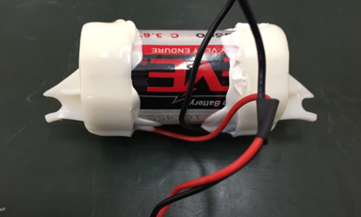**

**New seal: two pieces  
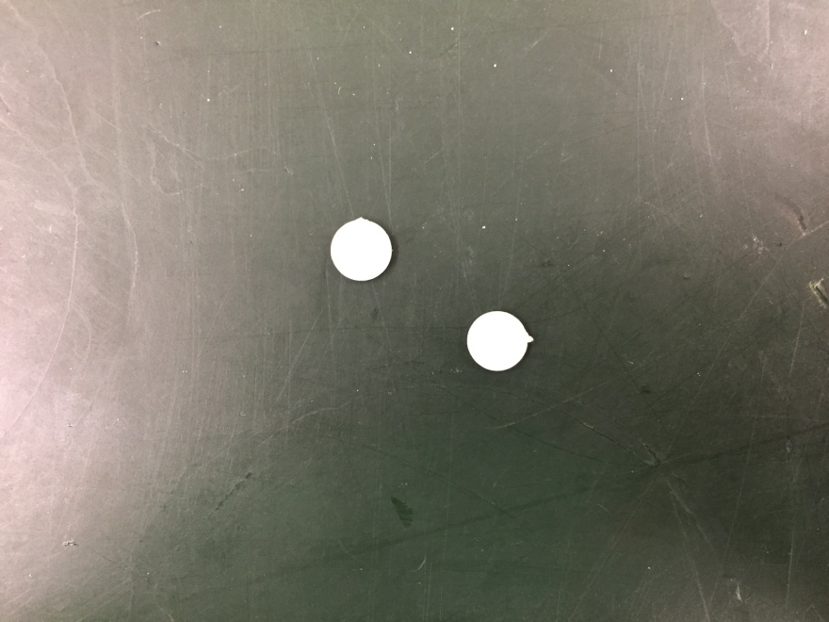**

**1” Heat shrink tube: 2pieces  
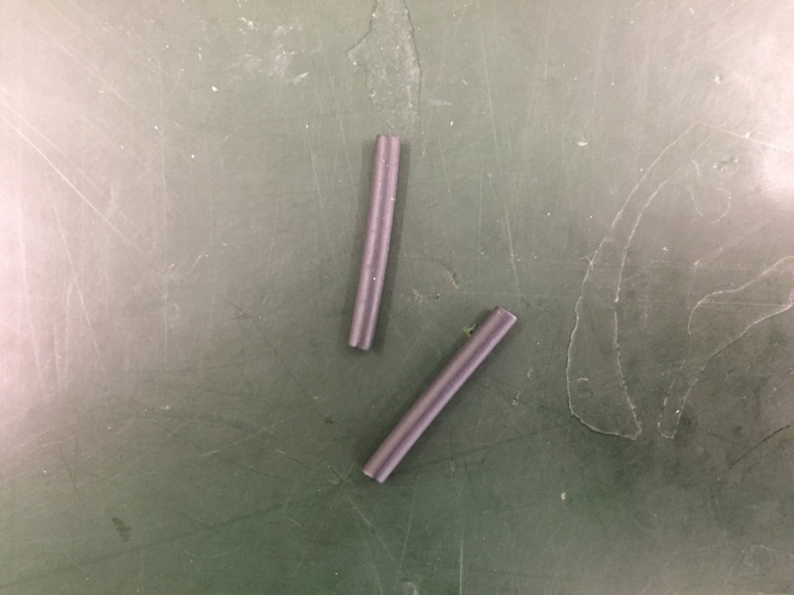**

**Tools:**

**Wire stripper:  
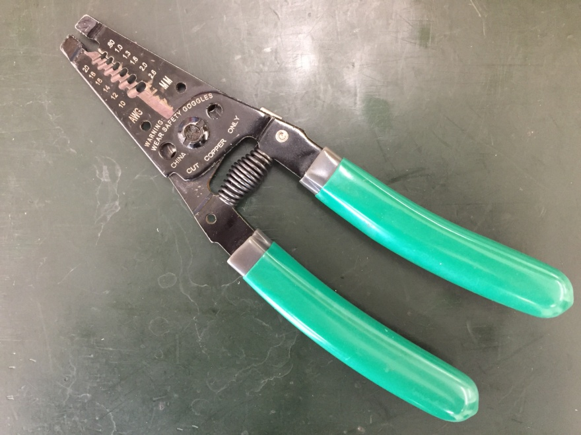**

**Solder:  
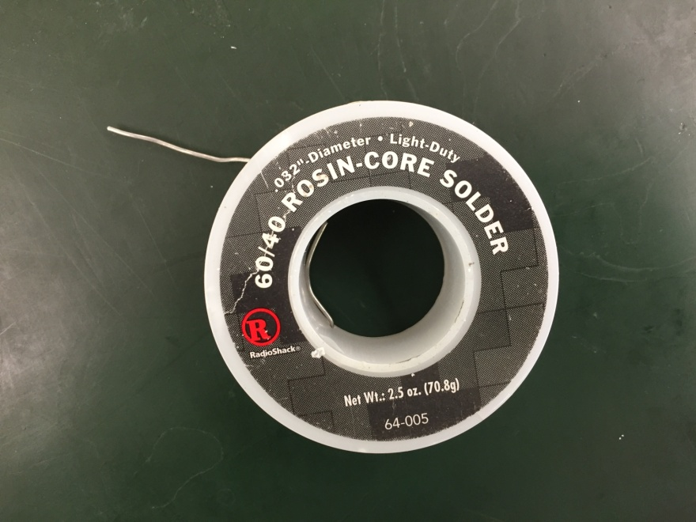**

**Heat shrink gun:  
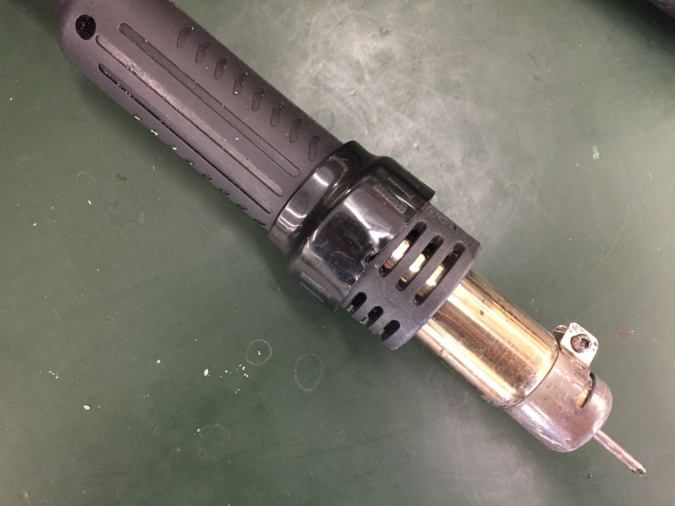**

1. **Remove the two seals.  
   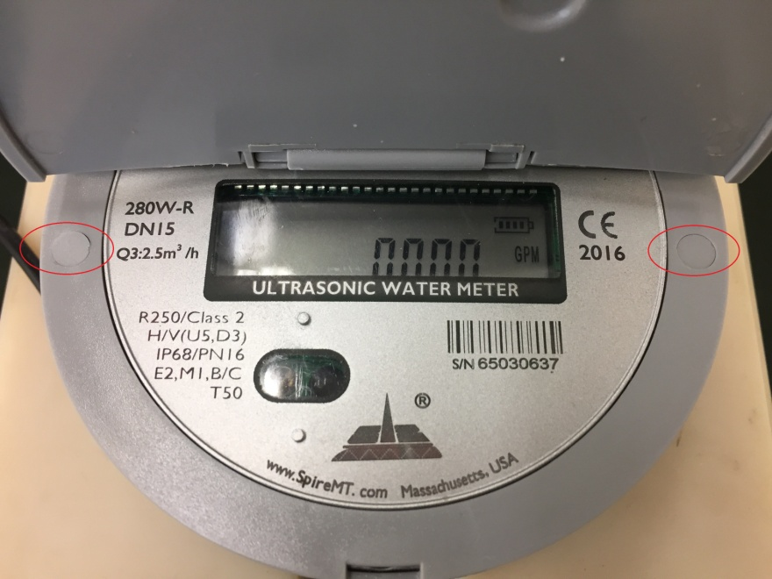**
2. **Remove the two screws.  
   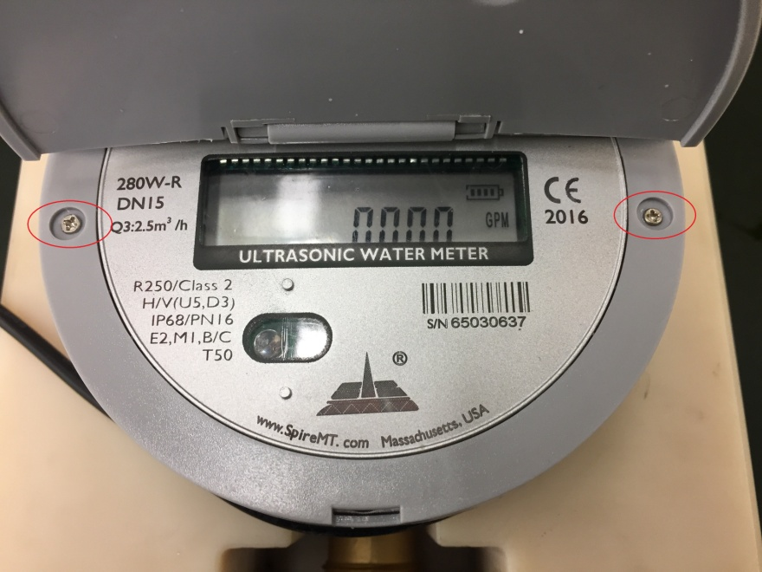**
3. **Remove the Cap.  
   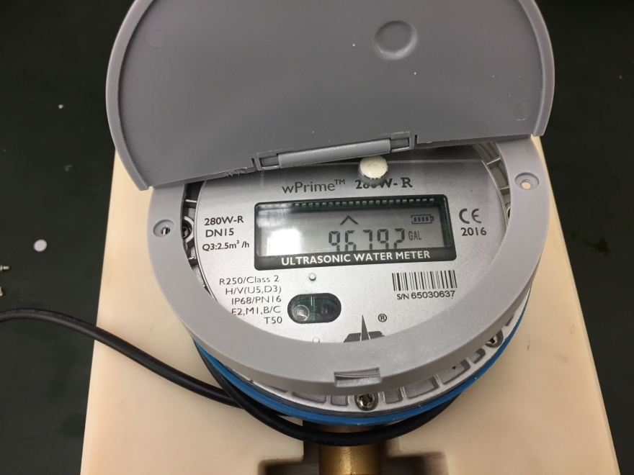**
4. **Remove the eight screws and open the core module.  
   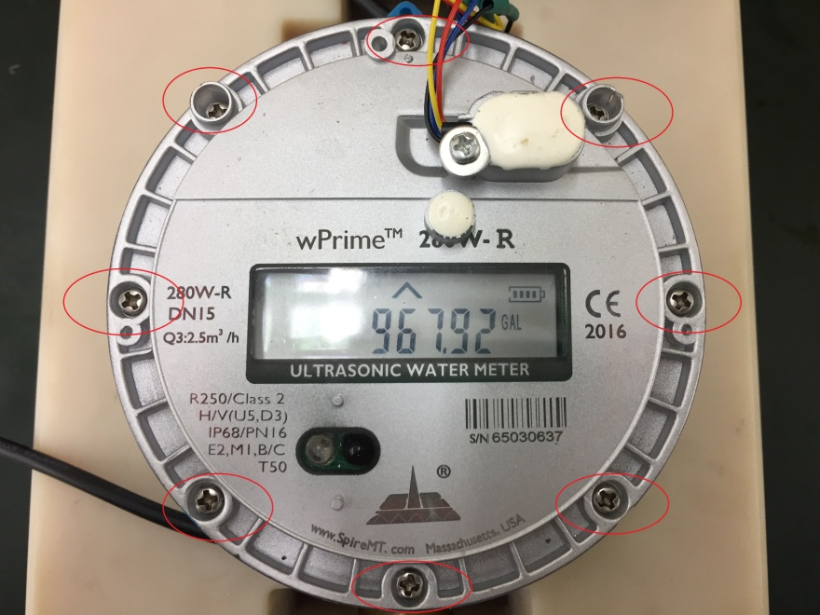**
5. **Cut the red and black wires connected to battery.  
   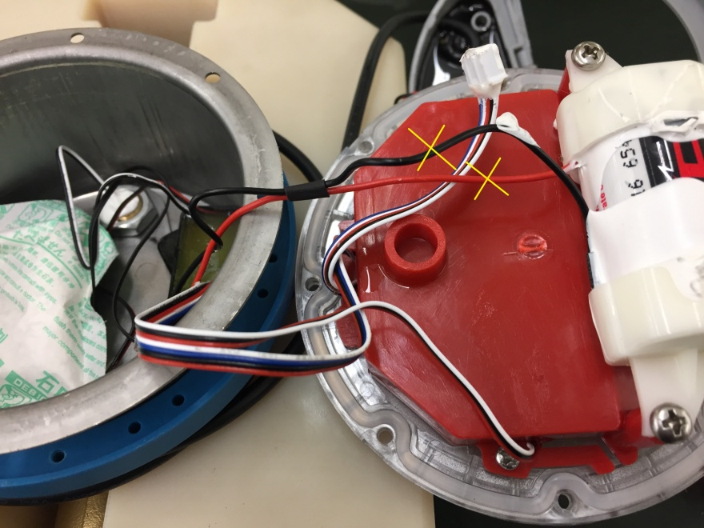**
6. **Remove the battery. Put a new battery in the battery holder  
   **
7. **Strip the wires on the meters and battery. Slid heat shrink tube onto the wires.**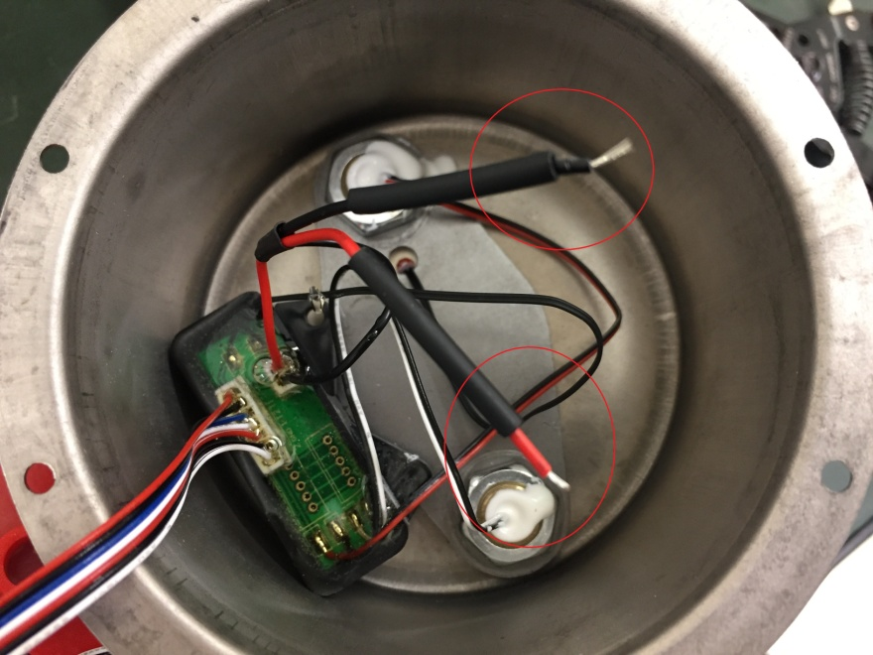
8. **Solder the black and red wires.  
   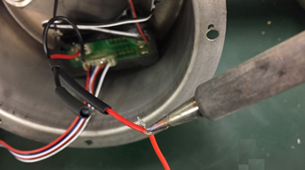**
9. **Use the heat gun to shrink the tubes.  
   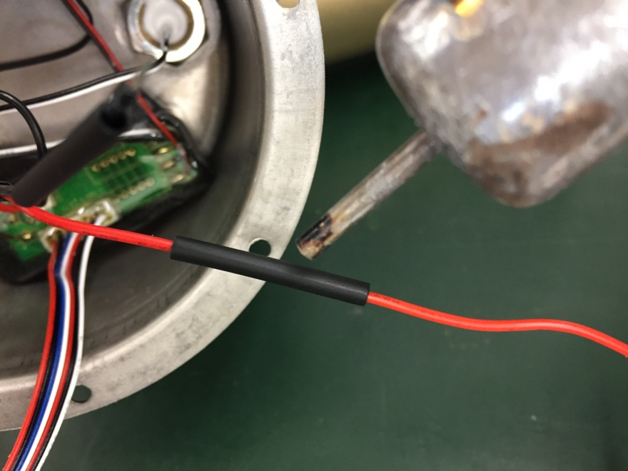**
10. **Close the core module, fasten the screws.**
11. **Snap the cap, fasten the screws and seals.**